2013 ACE Critique and Awards Program
NMSU Media Productions — Jeanne Gleason

Southwest Plant Selector  An iPhone/iPad App  Class 38:  Interactive Media Program | 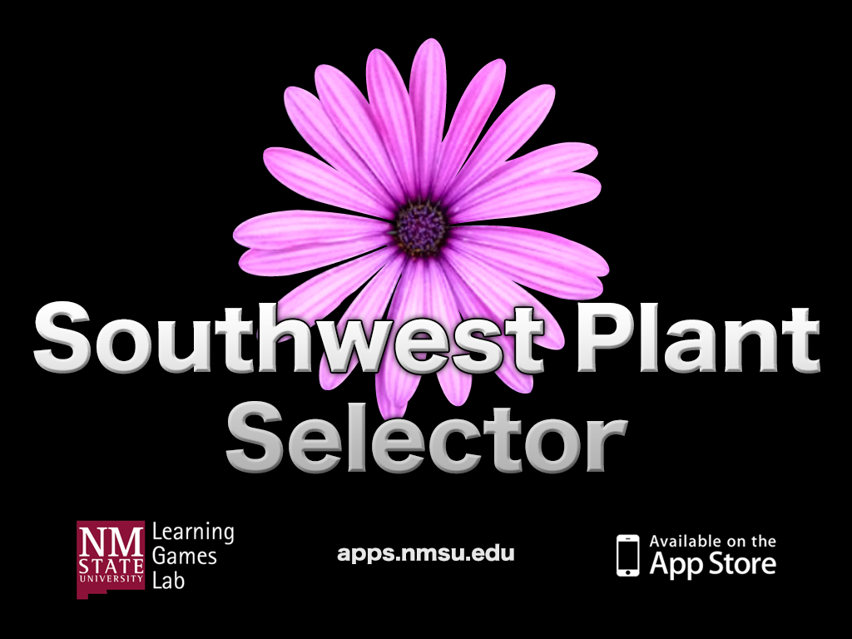
To look at a video demonstrating this project, visit ace.nmsu.edu/2013/College/Class38SWPlant.html
This link also offers screen shots from this iPhone/iPad app.
Overview:
While the Apple App Store offers hundreds of gardening and landscaping apps, only one, NMSU’s Southwest Plant Selector, is designed especially for the dry, hot, and high desert environments of the American Southwest and, more specifically, for New Mexico and surrounding areas. Most popular gardening resources do not address the extremely low water conditions common in much of the Southwest, which have long frustrated landscapers in these high deserts. Although irrigation is still an alternative, today’s environmental and cost-conscious landscapers are moving to native and xeric plants. This app not only suggests more than 750 plants that can thrive on little or no supplemental water, but also offers the user a way to filter by plant type, category, sun tolerance, and geographic region. This free app is an ideal tool for anyone wanting to establish an economical yet beautiful regional xeriscape.
Purpose (goals, objectives, need):
The goal was to create an easy-to-use mobile app that would allow landscapers to do their research and make plant selections before going to the nursery. The objectives were to allow users to sort potential plants by name, category (tree, shrub, perennial, annual), type (evergreen, deciduous, and sun requirement (sun/shade combinations), and geographical area. Another objective is to remain responsive to the needs of users; they have requested West Texas growing data, additional filtering criteria, more water conservation data, and more photos. NMSU has responded to these requests and is submitting an update (demonstrated in the video for this entry) to the Apple App Store.
Audience:
The need and demand for this app came from the audience, primarily Extension’s statewide network of Master Gardeners who outlined the specifications of what they needed to advise homeowners in their communities on how to save water and money by using more native plants.

Marketing/promotion:
The Southwest Plant Selector app has been in beta testing with a select group of Master Gardeners since late summer, and will be highlighted at this spring’s Master Gardener’s kickoff training. The Cooperative Extension Service will promote it through their offices in every county of the state, and the New Mexico Office of the State Engineer and the Center for Landscape Water Conservation, who contributed to the content, will also promote it with their clientele this spring and summer.
Role of each entrant for the project:
All work, including animation, programming and instructional design, was produced in NMSU’s Media Productions studios. The specific team for Southwest Plant Selector is listed in credits. The overall team includes programmers, content specialists, writers, editors, and volunteer Master Gardeners, as well as content experts and researchers from the New Mexico Office of the State Engineer and the Center for Landscape Water Conservation.
Extent to which project met goals and objectives:
Each feature of the Southwest Plant Selector was pilot tested extensively during development. Beginning in the fall of 2012, a select group of Master Gardeners conducted a more rigorous evaluation, as did a team of NMSU Extension agents. They feel that this iPhone/iPad app provides excellent resources, but once the Master Gardeners played with the app, they contributed even more plant photos and suggested color sorting and West Texas growing data. All these features have been incorporated into the latest update being submitted to the Apple App Store.
How diversity was incorporated into entry:
New Mexico’s overall population is 47% Hispanic and 10% Native American, and the state is often considered a bellwether for demographic changes to come across the United States. The deep historical roots and values of these two cultures have shaped the state’s culture. Master Gardeners often note that xeriscapes are nothing new in New Mexico, as local Native Americans and early Hispanics were experts in cultivating hardy low water landscapes. The popularity of irrigation in the past 50 years has lured many homeowners away from the past wisdom of water conserving plants. But now, low water availability and the commercial availability of native plants is encouraging a return to this historically important and sustainable ways of maintaining the landscape around homes.
Other information:
Southwest Plant Selector is the only app of expert-recommended xeric landscape plants specifically for New Mexico and surrounding areas. All plants in this app thrive on little or no supplemental water and are widely used in regional xeriscapes.

